PROJECT TITLE:
Understanding Remote Work Burnout: A Comparative Study of Regression and Clustering Techniques.
Contributors:
This project was developed and executed by Saira Abid, Zainab Bibi and M Nadeem.
INTRODUCTION:
The Work from Home (WFH) Employee Burnout Dataset provides detailed information about the daily and weekly activities of employees working from home, along with insights into their mental and physical well being. It records metrics such as hours worked per day, screen time, break durations, sleep hours, after hours work, burnout scores, and productivity. This dataset reflects the growing prevalence of WFH arrangements, which have changed the way people work by offering more flexibility and control over schedules, while also introducing challenges such as extended screen time and the risk of burnout from blurred boundaries between work and personal life. The absence of a physical office often makes it hard for employees to clearly separate professional and personal responsibilities. This can lead to longer workdays, after hours tasks, more time spent on screens, and irregular routines. Over time, these factors contribute to occupational burnout a state of mental and physical exhaustion that reduces productivity, engagement, and overall well being. As WFH and hybrid models become more common, understanding the factors that drive burnout in this environment is essential. Lifestyle choices play a key role in how employees manage work related stress. Sleep quality, physical activity, regular breaks, and the ability to mentally disconnect from work all influence mental fatigue, which can ultimately lead to burnout if neglected. Employees who frequently sacrifice personal time for work may experience reduced focus, irritability, and lower performance. Examining these factors provides a clearer picture of employee well being in a WFH setting. The Work from Home Employee Burnout project uses this dataset to study daily routines, lifestyle habits, and work related factors that affect burnout risk. It includes measurable data such as work hours, screen time, breaks, sleep, after hours work, task completion, and burnout scores. Derived features like work intensity (work hours / breaks taken), sleep debt (8 sleep hours), and productivity loss (100 task completion rate) are also included. Weekdays and weekends are distinguished through the day type feature, while demographic data allows analysis of burnout patterns across different groups, including comparisons between male and female employees. The project follows a structured, multi phase approach:
Phase 1: Exploratory data analysis (EDA), visualizations, feature engineering, and correlation analysis to identify the strongest predictors of burnout.
Phase 2: Development and evaluation of machine learning models Logistic Regression, Random Forest, XG Boost, and potentially Neural Networks to classify burnout risk (Low/Medium/High) and predict burnout scores, validated with cross validation and metrics such as accuracy, precision, recall, and F1.
Phase 3: Interpretability through SHAP/LIME explanations and rule extraction, for example: "If screen time > 12h and sleep < 6h → High Burnout Risk."
Phase 4: An intervention system with actionable recommendations ("Take 2 more breaks tomorrow" or "Reduce screen time by 1 hour") and simulations ("If meetings are reduced by 2, burnout risk decreases by X%").
Phase 5: Deployment of a simple web app (using Flask or Streamlet) for users to enter data and receive personalized risk scores and guidance.
Phase 6: Documentation, demo videos, and sharing insights through GitHub, LinkedIn, and Medium.
RESEARCH METHODOLOGY:
A. AN INTEGRATED ANALYTIC FRAMEWORK
With the growing adoption of remote and hybrid work arrangements, employee burnout has become a significant concern for both researchers and organizations. This study investigates burnout among employees who work from home by applying multiple analytical approaches. Relying on a single method may not fully capture the complexity of workplace challenges, therefore combining different methods helps provide a more comprehensive understanding of the issue. The analysis in this study incorporates both supervised predictive modelling and unsupervised pattern discovery techniques. The conceptual foundation of the research is based on the Job Demands Resources (JD R) model, proposed by Arnold Bakker and Evangelia Demerouti in 2017. According to this model, burnout develops when the demands placed on employees exceed the resources available to them. Job demands may include factors such as extended working hours, prolonged screen exposure, and frequent online meetings. In contrast, resources can involve adequate sleep, regular breaks, and a sense of satisfaction gained from completing work tasks. The dataset used in this research includes a variable referred to as the burnout score, which reflects this conceptual relationship. In simplified terms, the relationship can be expressed as:
Burnout Score ∝ (Demandᵢ − Resourceᵢ)
This relationship indicates that burnout tends to increase when job demands become greater than the resources available to employees. Although the dataset documentation does not provide a detailed explanation of how the burnout score was calculated, the formula illustrates the general principle behind the measurement. For the computational analysis, Python (version 3.12) was used within Google Colaboratory, an online platform that allows users to execute Python code without installing additional software. The platform provides convenient access to various tools required for data analysis. Throughout the study, each step of the analytical process from loading the dataset to interpreting the results was carefully documented to ensure transparency and to make the procedure reproducible for future research.
B. DESCRIPTION OF THE DATASET AND ITS INITIAL CHARACTERIZATION
The empirical basis for this study is the publicly available Work from Home Employee Burnout Dataset. It contains 1,800 observations, with each record representing an employee working in a remote environment. The dataset includes 11 variables that describe different aspects of the work from home experience and their possible relationship with employee burnout. Together, these variables provide useful information about working conditions and employee well being during remote work. The variables can be grouped into several categories that help explain burnout risk. The first category relates to workload intensity, which includes variables such as daily work hours, screen time, and the number of online meetings attended. These variables represent the workload experienced by employees in remote work settings and are often linked with higher mental fatigue and stress. The second category focuses on recovery and work life balance behaviors. This includes the number of breaks taken during the day, average sleep hours, and a binary variable indicating whether employees continue working after official work hours. These indicators are important because remote work can blur the boundary between personal life and professional responsibilities, which may increase stress and burnout. The third category includes performance related information, represented by the task completion rate. This variable helps to measure employee productivity and allows researchers to examine whether higher burnout levels affect work performance. For analysis purposes, the dataset provides two burnout-related outcomes. The first is a categorical variable called “burnout risk,” which classifies employees into different levels of risk. This variable can be used for classification and validation tasks. The second is a continuous variable called “burnout score,” which allows more detailed statistical analysis such as correlation and regression. Before starting the main analysis, an initial examination of the dataset was conducted to check its structure and data quality. Using the info () function in Python, it was confirmed that no variables contained missing values. Because the dataset is complete, no imputation or data replacement techniques were required. As noted by Little and Rubin (2019), the absence of missing data simplifies statistical analysis and allows researchers to focus directly on identifying patterns and relationships in the data. It also improves the reliability of the results because no estimated values are introduced into the dataset. The dataset contains both continuous and categorical variables, which makes it suitable for different types of statistical analysis, including descriptive statistics, regression analysis, and classification methods. In addition, the sample size of 1,800 observations is large enough to support reliable analysis and model evaluation. However, one limitation should be noted. The dataset was obtained from the Kaggle platform and was created for learning and competition purposes rather than collected through real organizational surveys. Although synthetic datasets are useful for practicing data analysis and model development, they may not fully represent real workplace conditions. Therefore, the results of this study should be interpreted carefully when applying them to real organizations or employee populations (see Section 4).
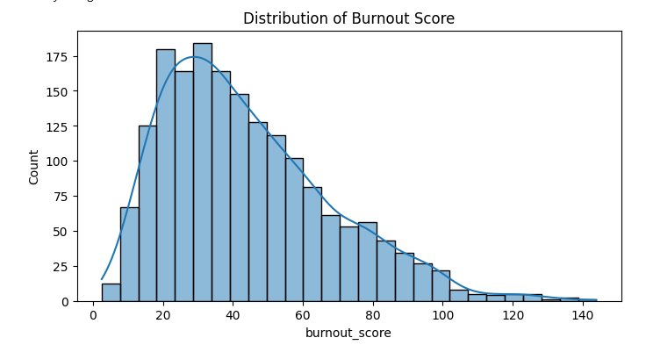
Figure 1: Distribution of Burnout Scores across the Dataset
Figure 1 illustrates the distribution of the target variable (Burnout Score). The visualization suggests that the burnout levels are distributed across a wide range, providing a diverse basis for both the regression and clustering analyses.
C. FEATURE ENGINEERING AND DATA TRANSFORMATION
To make the raw data suitable for analysis, a systematic preprocessing approach was applied. Eight predictor variables day type, work hours, screen time hours, meetings count, breaks taken, after hours work, sleep hours, and task completion rate were selected from the dataset based on their theoretical relevance to the determinants of burnout. To support the matrix based computations required by machine learning algorithms, the categorical variable day type was transformed into numeric values using label encoding, where Weekday and Weekend were represented by 0 and 1 respectively, without suggesting any ordinal order. To maintain reproducibility, the dataset was randomly partitioned into training and testing sets using a fixed random seed, where 80 percent of the data (n = 1,440) was used for training and the remaining 20 percent (n = 360) for testing. To prepare the data for clustering analysis, StandardScaler was used to standardize the features, ensuring that each variable had a mean of zero and unit variance. This step addresses a fundamental limitation of K Means clustering, as the algorithm relies on Euclidean distance measurements that are sensitive to differences in the scale of variables. In the absence of standardization, variables with smaller value ranges, such as meeting count, have less impact on cluster formation. In contrast, variables with larger numerical ranges, such as work hours (which vary between two and twelve hours), exert a greater influence on the clustering results. As a result, the clustering results may become biased.
D. REGRESSION MODELING AND COMPARATIVE PERFORMANCE EVALUATION
During the supervised learning phase, three regression models were tested to compare their levels of interpretability and predictive performance. In this study, linear regression was used as the parametric baseline because it generates interpretable coefficients that highlight the marginal contribution of each predictor and provide a benchmark for evaluating model performance. The Random Forest Regressor (Breiman, 2001) is an ensemble method that doesn’t rely on a predefined theoretical model. It is capable of capturing complex nonlinear relationships. Additionally, it provides a degree of interpretability through the use of feature importance metrics. The predictive power extreme of the spectrum was represented by the XGBoost Regressor (Chen & Guestrin, 2016). It employed gradient boosting, incrementally adding trees to correct errors from previous rounds, while using regularization techniques to reduce overfitting. The model's performance was evaluated using three complementary metrics. These included the Coefficient of Determination, which indicates the variance explained; the Root Mean Square Error, which emphasizes prediction consistency through quadratic penalization; and the Mean Absolute Error, which is expressed in the original burnout score units for easy interpretability. Table 1 (see Appendix) indicates that the Random Forest method outperformed both Linear Regression (R² = 0.9333) and XG Boost (R² = 0.9311), achieving an R² of 0.9340 along with an RMSE of 6.1003. The feature importance analysis of the Random Forest model showed that the three top predictors work hours, screen time hours, and sleep hours contributed the most to the overall relative importance.
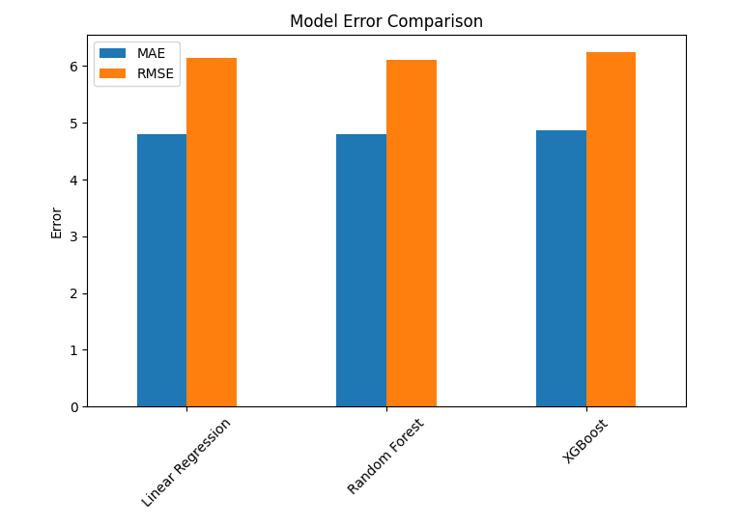
Figure 2: Comparison of Actual vs. Predicted Burnout Scores
Figure 2 showcases the relationship between the actual burnout scores from the dataset and the values predicted by the Random Forest model. The close alignment of the data points along the diagonal line confirms the model's high predictive accuracy, consistent with the $R^2$ score of 0.9364 reported earlier.
E. HYPERPARAMETER OPTIMIZATION AND MODEL REFINEMENT
To improve the model’s performance beyond the default settings, a structured hyperparameter optimization process was applied to the Random Forest algorithm using grid search along with 5 fold cross validation. The objective of this approach was to maximize the cross validated R² by examining various parameter combinations, including n estimators [50, 100, 200] which determine the number of trees in the ensemble, max depth [5, 10, 15] that controls tree complexity, and min samples split [5, 10] which defines the minimum samples required to split a node. The optimal parameter configuration (n estimators= 100, max depth=10, and min samples split=10) achieved a cross validated R² score of 0.9207, reflecting a suitable balance between model complexity and its ability to generalize well to unseen data. This configuration reduces the chances of overfitting to random noise while preserving the model’s capability to learn significant patterns from the data. When evaluated on the previously reserved test set, the tuned model achieved an R² score of 0.9364, indicating that the optimization improved prediction accuracy compared with the default configuration. To support future deployment and efficient prediction, the finalized model together with its preprocessing components, such as the fitted StandardScaler and label encoder, was saved using the joblib library. To verify the effectiveness of the saved model, a sample prediction was performed using a hypothetical employee profile, which confirmed that the model works properly and can be used for practical prediction.
Table 1: Optimized Hyperparameters and Regression Performance
Model Parameter / Metric | Optimized Value
Max Depth | 10
Min Samples Split | 10
Number of Estimators (n_estimators) | 100
Final Test R² Score | 0.9364

The table above summarizes the best-performing parameters identified during the hyperparameter tuning process, resulting in a high predictive accuracy ($R^2 = 0.9364$)
Table 2: Employee Distribution Across Identified Clusters
Cluster Number | Number of Employees (n) | Percentage (%)
Cluster 0 | 588 | 32.7%
Cluster 1 | 873 | 48.5%
Cluster 2 | 339 | 18.8%
Total | 1800 | 100%

The table above presents the distribution of 1,800 employees across three distinct clusters based on their work patterns and burnout characteristics.
F. UNSUPERVISED LEARNING AND METHODOLOGICAL CONSIDERATION
To identify natural employee groups and complement the regression findings, K Means clustering was applied to the standardized feature set. By minimizing the sum of squared distances within clusters, this technique organizes observations into groups that share similar behavioral patterns, independent of burnout outcome values. According to the elbow method analysis, the optimal number of clusters was identified as k = 3, since additional clusters resulted in only marginal improvements in variance explanation. To improve visual interpretation of the clustering results, Principal Component Analysis (PCA) was used to reduce the eight dimensional feature space into two dimensions while retaining the maximum possible variance (see Figure 1 in Appendix). As shown in Table 2 (see Appendix), the three cluster solution identified several employee groups, each displaying distinct behavioral characteristics. Cluster 0 (n = 588) was primarily composed of weekday workers with moderate working hours (mean = 4.58) and exhibited the lowest average burnout level (mean = 40.84). The largest cluster, Cluster 1 (n = 873), was characterized by predominant weekend work patterns, the highest levels of work hours (mean = 8.57) and screen time (mean = 11.34), and relatively higher burnout scores (mean = 46.79), indicating possible work intensification. Cluster 2 (n = 339) was characterized by consistent after hours work participation and moderate burnout scores (mean = 42.35), indicating a potential relationship between boundary violations and burnout independent of overall work hours. Overall, these patterns highlight how burnout risk is associated with certain behavioral profiles while also confirming the results produced by the regression analysis. Nevertheless, several methodological limitations should be noted. Although the dataset is detailed, it was generated from a synthetic Kaggle source rather than collected directly from real organizational settings, which may limit its generalizability. Furthermore, certain key variables, such as burnout score and task completion rate, are likely derived from self reported data, which may introduce response biases commonly observed in survey based studies. Because the dataset documentation does not disclose the exact formula used to compute the burnout score variable, the conceptual model presented in Section 3.1 should be considered a theoretical interpretation rather than a reconstruction of the original algorithm. Future investigations should aim to validate these findings by using well documented burnout measurement methods, more diverse organizational samples, and objectively measurable indicators. Despite these limitations, the integration of multiple analytical approaches contributes to a more comprehensive understanding of employee burnout than a single method could achieve.
Table 3: Mean Feature Values across Identified Employee Clusters
Cluster | Work Hours | Screen Time | Meetings | After Hours Work | Burnout Score (Mean)
Cluster 0 | 4.57 | 7.31 | 0.95 | 0.00 | 40.83
Cluster 1 | 8.57 | 11.34 | 2.95 | 0.35 | 46.79
Cluster 2 | 4.58 | 7.32 | 1.02 | 1.00 | 42.34

Note: The values represent the average (mean) for each metric within the respective clusters, highlighting the distinct behavioral profiles of employees.
CONCLUSION:
In conclusion, the Work from Home Employee Burnout project provides a comprehensive framework for understanding, predicting, and managing burnout among employees working from home. By combining behavioral analysis, lifestyle factors, mental fatigue assessment, demographic comparisons, and actionable recommendations, the dataset and tools offer a practical foundation for organizations, employees, and researchers aiming to foster healthier work habits and sustainable routines.
ACKNOWLEDGEMENT:
This project was successfully completed under the expert guidance of our supervisor, Sir Azhar Ali, whose mentorship was invaluable throughout the process. Regarding the team’s contribution, Zainab Bibi handled the entire coding and model implementation in Python, while Saira Abid developed the research methodology and analytical framework. M Nadeem was responsible for data acquisition from Kaggle and initial preprocessing. We are deeply grateful to our supervisor and the team for their collective efforts in making this empirical study a success.

